**(5) Land Reform + Communalism + National Integration**

(not for prelims this is important for mains.)

Land reforms and Issues:

1. More than 2/3rd that is 71% of Indian farmer were land less. Hamza alwi divided the India farmer into 4 categories.
   1. Large and rich farmer owning more than 10-acre land.
   2. Middle farmers own 5 to 10 acres.
   3. Small farmers with 2 to 5 acres.
   4. Marginal farmers have less than 2 acres.
2. Among them perforation of marginal farmer was the largest with 71% having no land holding.
3. Marginal farmers also face frequent evictions due to poor legal protection and absence of robust tenancy laws.
4. Another main problem with India agriculture was high rural inverness due to lack of availability of formal credit. 1955 RBI survey revealed that only 7% of all farmer avail credit for organized bank. The lack of formal credit was leading to other problems such as land lessness and bonded labor.
5. Technological backwardness was another short coming Indian agriculture.
6. Most farmers relied upon primitive methods according to government survey on 3% farmers were using the iron plough.
   1. They did not have access to synthetic fertilizers pesticides high yield variety seeds or climate resistant crop.
   2. As a result, India agriculture was stagnant, growing at a rate .5 % per annum.
   3. On the other hand, the population increased at a rate of 3% per annum.
   4. Due to this missed match, the country was facing food scarcity, inflation and food insecurity. This compounded other problems such as sub nationalism, separatism, and foreign aggregation.

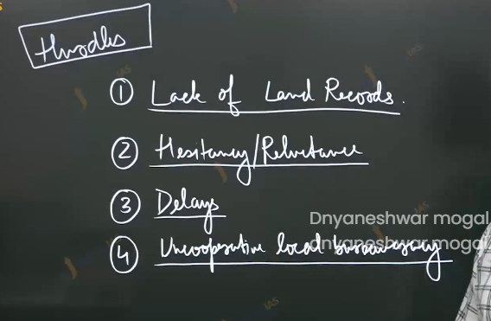

Hurdles to the land reforms:

1. Lack of land reforms
   1. Due to inadequate and outdated land reforms, the clear picture of land holding was difficult to create. Without this task such as distributing land putting a land sealing almost impossible to execute.
2. Hesitancy from leading politicians:
   1. Since many politicians were large landowner themselves there was lack of political will to bring about meaningful reforms with regards to owner ship tenancy and credit availability as such major delay policy making process.
3. Even after movement was created towards the land reforms the process was delayed due to legal and political hurdles Right to property had enshrined in the constitutions as fundamental right and confiscations of land would have invited the judicial reviews as such ceiling laws and land distribution programs invited large scale litigation.
4. Feather in the era of electoral politics, land reforms emerged as politically charged issue and was used by the dominant cast group to derail and delayed meaning full reforms.
5. For land reform to be carried out the cooperation of local bureaucracy including official such as patwari and the panchayat was crucial. However, since wasted interest official directly and indirectly linked with large land holders the cooperation was not forth coming.

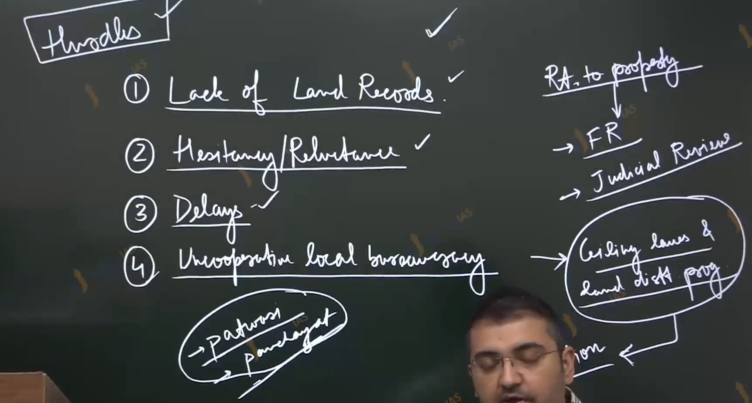

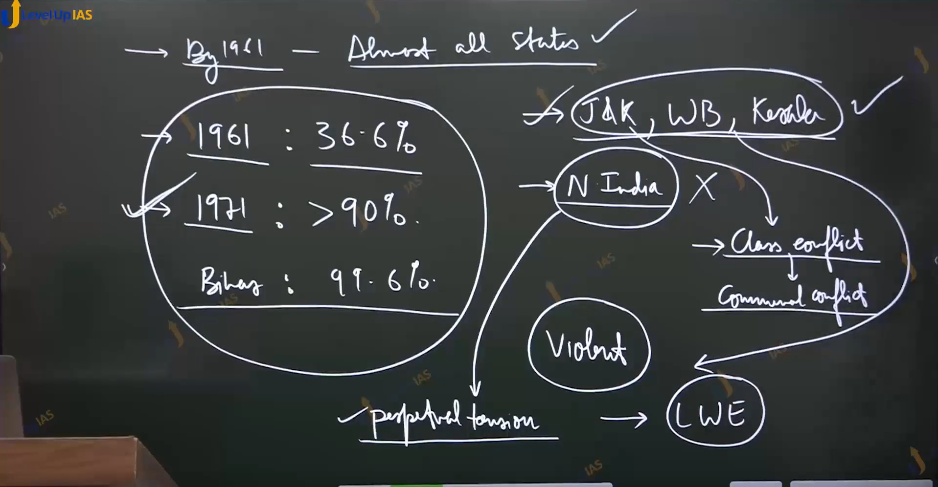

Efforts or laws

1. Since land is a state subject, the state had to take a lead in land reforms. The UP-state assembly pass the zamindari abolition act 1949 to initiate the process. This act became the model law for other states.
2. However, land reforms ran into legal hurdles as ceiling laws, confiscation of land writing of desk were challenged in the court.
3. The parliament responded by enacting the first constitutional amendment act which removed the right to property as fundamental rights and introduced the 9th schedule to protect specific laws from the judicial review.
4. By 1961 almost all states had enacted their own land ceiling act finding the maxing the land between the 3 to 27 acres.
5. According to the 1961 census 36.6% landowner by 1971 this figure increased to 91.6 present with Bihar is topping the list 99.6% whoever these figures were deceptive, the process of land reform had been derailed by the non-cooperation of local officials. collusion of government agencies with large landowner, influence of vote bank Polites and rise of benami land holding.
6. As such frustrated aspiration of marginal peasants paved the way for emerges of radicalisms which manifested in the Naxalite movement and banded of Chambal. Even in those area where land reform is more successful were problematic
7. In Jammu and Kashmir Sheikh Abdullah government sincerely carried out land distribution but no compensation given to large landowner who primary in Kashmiri pandit. This flared the communal tensions. And has disturbed Kashmiri politics permanently.
8. in west Bengal and karela land reform were carried out effectively often companied by large scale violences, that created political instability and slowed down the economic growth.

01:04:00